Lab 5
5.1 Design a class Multiply_calc extends it from Calculation class.
Calculation class should keep the following information:
i. Variables / Properties / Attributes
· result
ii. Methods
· Addition(int x, int y)
· Subtraction(int x, int y)

Multiply_calc class has following method:
· Multiplication(int x, int y)
Make object of Sub class and access methods of super and sub class.

Source Code
class calculation:
result = 1

def adition(self, x, y):
print("This is addition function")

def Subtraction(self, x, y):
print("This is Subtraction function")

class Multiply_calc(calculation):
def Multipication(self, x, y):
print("This is Multipication function")

nabeel = Multiply_calc()
nabeel.Multipication(1,2)
nabeel.result
nabeel.adition(3,4)
nabeel.Subtraction(5,6)

Output
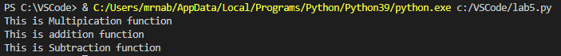

5.2 A class called circle is to be draw that contains:
· Two private instance variables: radius (of the type double) and color (of the type String), with default value of 1.0 and "red", respectively.
· Two overloaded constructors - a default constructor with no argument, and a constructor which takes a double argument for radius.
· Two public methods: getRadius() and getArea(), which return the radius and area of this instance, respectively.
· Make a child class square and inherit with parent class & call variables in child class.
· Make an object of that class and execute it.
Source Code
class circle:
__radius = 1.0
__color = 'red'

def __init__(self):
print("This is frist default constructor")

def __init__(self, radius):
circle.__radius = radius

def getRadius(self):
print("The radius is: ", circle.__radius)

def getArea(self):
answer = 3.14*circle.__radius*circle.__radius
print("Area is equal to: ", answer)

class square(circle):
print("The radius is: ", circle.radius)
print("The area is: ", circle.answer )

radius = input("Enter radius: " )
radius = float(radius)

nabeel = square(radius)

Output
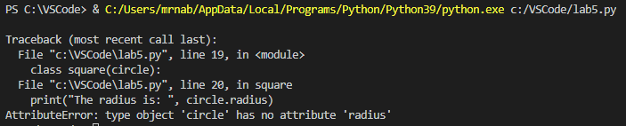

5.3 write a program to perform the hierarchical inheritance.
Source Code
class teacher():
print("This is teacher class")
teachername = 'SirFaheem'

class student1(teacher):
print("This is 1st student sub-class")
teacher.teachername

class student2(teacher):
print("This is 2nd student sub-class")
teacher.teachername

nabeel = student2
print(nabeel.teachername)
Output
